Ideation Phase
Brainstorm & Idea Prioritization Template
31 January 2025

Date | 30 September 2026
Team ID | SWTID-2026-7613
Project Name | Auto Ticket Classification using Flow Designer
Maximum Marks | 4 Marks

Brainstorm & Idea Prioritization Template:
Brainstorming provides a free and open environment that encourages everyone within a team to participate in the creative thinking process that leads to problem solving. Prioritizing volume over value, out-of-the-box ideas are welcome and built upon, and all participants are encouraged to collaborate, helping each other develop a rich amount of creative solutions.
Use this template in your own brainstorming sessions so your team can unleash their imagination and start shaping concepts even if you're not sitting in the same room.
Reference: https://www.mural.co/templates/brainstorm-and-idea-prioritization

Step-1: Team Gathering, Collaboration and Select the Problem Statement
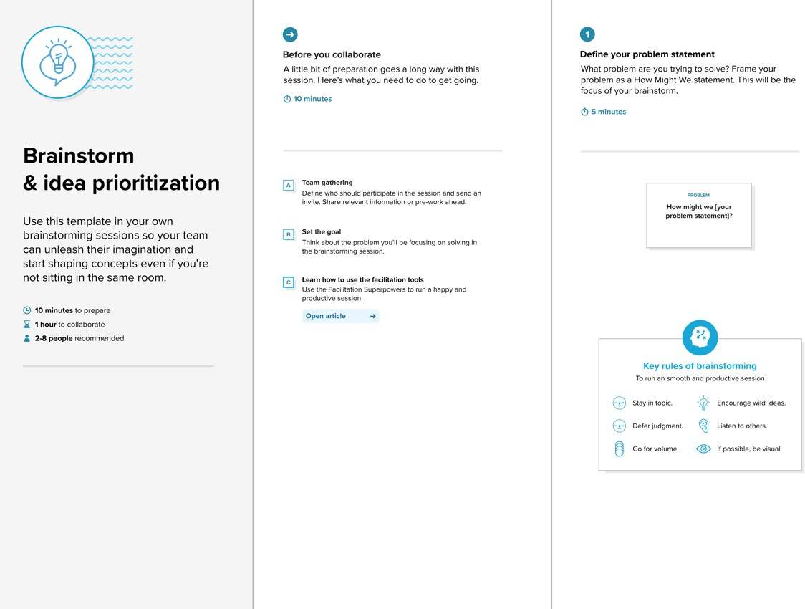
classify school IT tickets at creation to reduce manual effort and improve routing?
How might we automatically

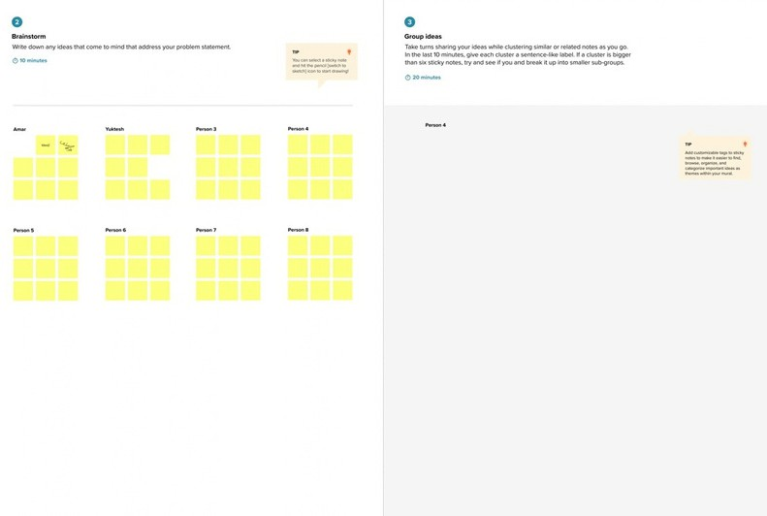









Step-2: Brainstorm, Idea Listing and Grouping
Vijay Ragavan S
Kirubakaran S
Dinesh B
Sadasivakrishnan R S
Vijay Ragavan S
classify match Network
Auto Keyword WiFi →
Email No-code Trigger:
Reduce Faster Easy to
tickets
to caller Flow Category
Designer is empty
manual routing maintain
effort
Update Export Future: Set XML SLA
Projector Password Slow PC
- Hardware → Access → Perf.
Update Test:
Identify the issue type
from Short Description keywords
+ Subcat.
Category WiFi
Update Category and Subcategory automatically
ticket
WiFi /
Network
Projector
Network >
Wi-Fi
Hardware >
Projector
Ragulraj H
Password /
Login
Slow /
Hanging
Access >
Forgot Password
Performance >
Slow Computer
send email wi-fi
email message test

projector check
test
email
Confirm submission to the caller by email
Build it no-code and keep it maintainable
Confirmation
email sent
Caller notified
of submission
Flow
Designer
No-code
automation
Sent after
classification
Update Set
(export XML)

Step-3: Idea Prioritization
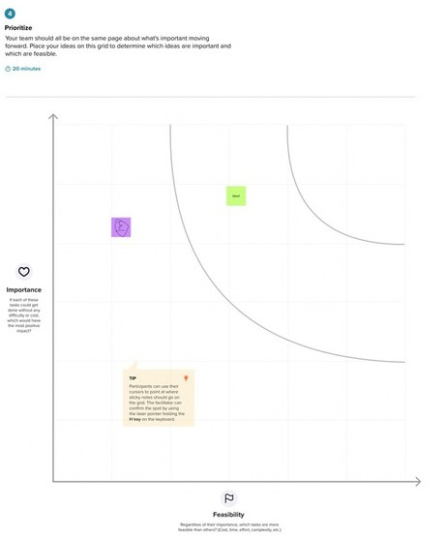

Keyword
auto-classify
Email to
caller
Assign-
ment auto (future)
Predictive
intel. (future)
No-code
Flow Designer
SLA track
(future)
Update Set deploy

